Name:

Job or Career Choices
Watch: https://youtu.be/fY1WoHkNGy4

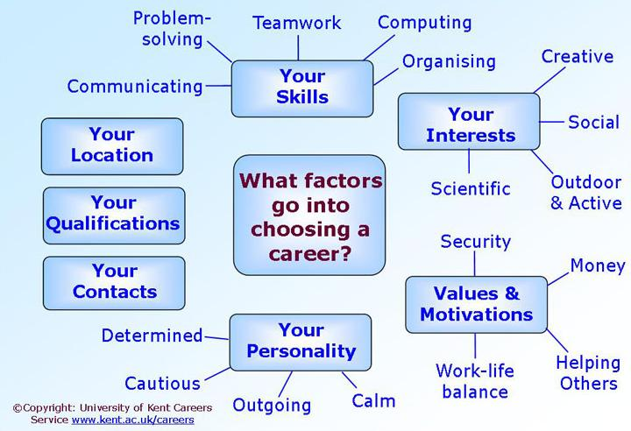

What Is the Difference Between a Job and a Career?

Depending on the type of work you'd like to do, the differences between a job and a career might be worthwhile to consider. Based on your goals and self-fulfillment desires, having a career could be more meaningful rather than just having a job to get by. This article will discuss what it means to have a job, and likewise, what it means to have a career. It might be easy to assume there's no difference between a job and a career, but the educational requirements, personal satisfaction and salary opportunities separate the two words. For example, you might hold a job before you complete an education; afterward, you might embark on a career.

Differences in Education

Levels One of the major differences between a job and a career is the amount of education you'll need to obtain a position. In a career, you'll probably need some type of formal education, whether it's an associate degree or a master's degree. Jobs may not have specific educational requirements. For example, if you wanted to enter a career in finance, you'd most likely need a degree; however, if you wanted to hold a job in retail sales, you could probably do so with only a high school diploma or its equivalent. Many college students take jobs while they're earning the degrees that will let them pursue careers.

Differences in Fulfillment

Sometimes a job is viewed as a means to an end. You might take a job to pay the bills, reduce debt or earn extra cash. A career is generally a vocation that you have chosen to bring a sense of enjoyment, fulfillment or importance. Instead of merely working to make money, having a career can let you find more meaning in the work you do. You will still make money in your chosen career, but the satisfaction you'll get from doing your work will be just as important as this financial gain.

Differences in Advancement Opportunities

When you decide on a career, you most likely put some thought into your future and your goals. You might decide which position you'd like to eventually hold and what you can do to accomplish this goal. With a job and no education, you are less likely to earn a promotion. This isn't to say that you can't advance in a job. If you find that you are dedicating more time and effort to your advancement potential, it's possible that your job can become your career. You'll find that this effort and planning are a large part of what makes a career.

How to Find a Career

If you don't know what type of career you'd like or you're unsure how to begin your chosen career path, you have options. Many schools offer career services and counseling that can help you discover what type of work you'd enjoy. If you already have an idea of the kind of work you'd like to do, you might try obtaining a part-time job or internship in your chosen field. Even if it doesn't work out, you'll know why and can apply this knowledge to your future career search. If you enjoy the job, you might already be on your way to a career.

Unskilled:
A job that requires no specialized training for a person with no training and possibly no high school diploma. In addition, these jobs usually have low wages.

List examples:
1.
2.
3.
4.
5.

Specialized Training:
A job that requires a certificate or a certain amount of training to learn the necessary skills. These jobs can pay an average wage.

List examples:
1.
2.
3.
4.
5.

Post-Secondary Degree:
These are the jobs that requires a Bachelor’s or Master’s Degree. These jobs pay an above-average salary.

List examples:
1.
2.
3.
4.
5.

